(Approx. 838 words)

The Sunk Cost Fallacy
By David Kretchmar, Hardware Technician
Sun City Summerlin Computer Club
https://www.scscc.club
dkretch (at) gmail.com

In 2017, Richard Thaler, a professor at the University of Chicago, was awarded the Nobel Prize in Economic Sciences for his contributions to behavioral economics.

One of Thaler's main themes is that market-based economic models are incomplete; he is quoted as saying, "conventional economics assumes that people are highly-rational —super-rational— and unemotional; they can calculate like a computer and have no self-control problems. But, in reality, we all are susceptible to a wide array of routine biases that can lead to an equally wide array of embarrassing blunders in education, personal finance, health care, mortgages and credit cards, happiness, and even the planet itself."
One of the biggest factors that cause humans to make irrational decisions is known as the Sunk Cost Fallacy.

A sunk cost is any cost that has already been paid and cannot be recovered. The sunk cost fallacy reasoning states that further investments or commitments are justified because the invested resources will be lost otherwise. Therefore, the sunk cost fallacy is a mistake in reasoning in which the sunk costs of an activity are considered when deciding whether to continue with the activity. This is also known as "throwing good money after bad."

The sunk cost mistake is often made for the worst possible reasons. People hate to admit that they have made a mistake and will go to great lengths to avoid that admission, even when they have ample evidence that not admitting a mistake will lead to even more significant losses. Politicians highly paid corporation executives, and others in the public eye do not like to admit they made poor decisions.

The Concord Fallacy

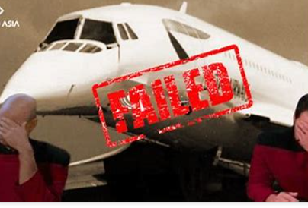
The Concorde fallacy has routinely been cited as a perfect example of the sunk cost fallacy. The Concord fallacy refers to both the British and French governments continued funding of the project even as they knew there was no economic case for the aircraft. They knew it was a commercial and environmental disaster, but political decisions made it impossible for either government to pull out.

I don't feel this example is cut and dried because of other factors such as possible harm to Anglo-French relations, the loss of tens of thousands of jobs when the world's economy was weak, and consideration of "national pride." What appears to be a perfect example of the sunken cost fallacy today, in retrospect, looked very different in 1972.

Other Examples

On a much smaller personal scale, have you ever over-eaten at a buffet, even if the food was not very good, because you had already paid for "all you can eat"? Have you seen someone refuse to quit a slot machine because of all of the money they had already "invested" in it? Have you held on to an investment for much longer than you originally intended because you were reluctant to sell at a loss? All are examples of sunk costs and the false belief that non-recoverable expenditures have some value, leading to poor decisions.

The Old Computer

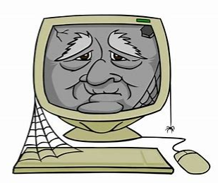
In our everyday lives, the all too human tendency to place a value on something that has no value often leads to a poor decision. Some individuals use computers well beyond their expected useful life, which is about six years. Some computers, especially if they were originally above-average systems, can provide good service for over six years. However, time takes its toll on electronics just like it does on people. Computers tend to get slower with age, and with age, computer users will get more and more "Not responding" popups and other annoyances.

Rather than replace a computer, it is amazing how much slowness and other problems some users will endure. After a computer reaches a certain age, even significant upgrades, like replacing a mechanical hard drive with an SSD, will only delay the inevitable. Even after installing a new SSD, the system's other components are still old and nearing the end of their life. The wise course is for the user to bite the bullet and buy an adequate new computer.

Conclusions

Any time you allow the sunk cost fallacy to influence decisions, you're going to make it harder and harder on yourself to let go in the future. So essentially, falling victim to sunk cost bias not only means you're making a poor decision now but increases the chance you'll continue to make a wrong decision in the future because, at that point, you'll be even more invested.

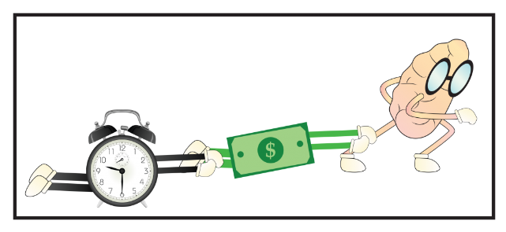
Are you spending time or money on something because of the time or money you already have invested? If so, I urge you to step back from what you're doing and evaluate the situation logically by asking yourself, "Is this the best use of my time or money at the present moment?"

This is a bigger problem than many of us realize, and it's negatively impacting our lives. Sunk cost fallacy leads to poor decisions, which leads to sub-optimal results, which leads to decreased long-term happiness.

